✅ Can We Change Thread Name Using setName()?
Yes ✔
It is completely valid and allowed.
public final void setName(String name)
public final String getName()
You can:
- Set thread name using setName()
- Get thread name using getName()

🔹 Example 1: Changing Name After Creation
class MyThread extends Thread {
@Override
public void run() {
System.out.println("Running in: " + getName());
}
}
public class Modify_Name_Of_Thread {
public static void main(String[] args) {
MyThread t = new MyThread();
t.setName("Worker-Thread"); // Changing name
t.start();
}
}
✔ This is perfectly valid.

🔹 Example 2: Changing Main Thread Name
public class Modify_Name_Of_Thread_Eg2 {
public static void main(String[] args) {
Thread.currentThread().setName("Main-Thread");
System.out.println(Thread.currentThread().getName());
}
}
✔ Even main thread name can be changed.

✅ Industry Recommendation
There are two ways to set thread name:
1️⃣ Using Constructor (Preferred)
Thread t = new Thread(r, "Payment-Worker");
Why preferred?
- Name is set at creation time
- Clean and readable
- No risk of forgetting to set name
- Good practice in production systems

2️⃣ Using setName() (Also Valid)
Thread t = new Thread(r);
t.setName("Payment-Worker");
t.start();
This is also correct.
But:
- Slightly less clean
- Two-step process
- Easy to forget in large codebases

Eg: Thread_Name_Demo

1️⃣ Thread Priority
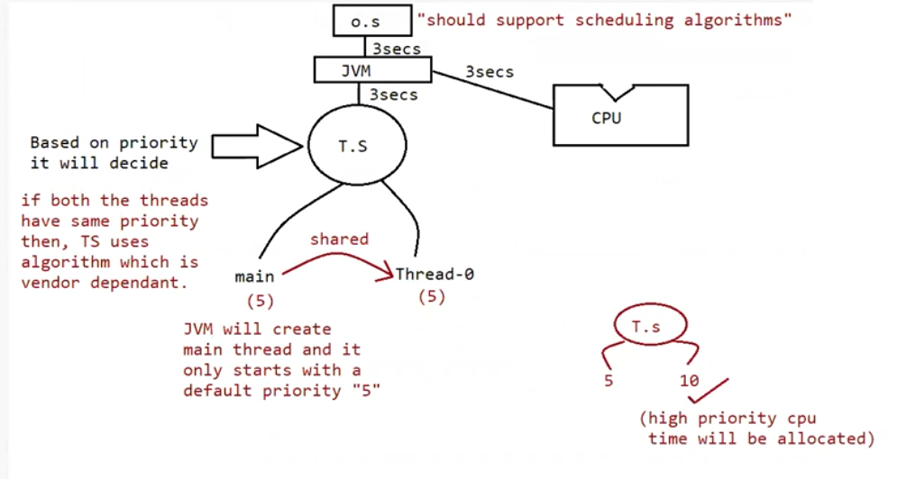
What is Thread Priority?
Every thread in Java has a priority value.
Thread priority is a number that is used by the Thread Scheduler to decide which thread should get CPU time first.
A higher priority thread has a higher chance of getting CPU time compared to a lower priority thread.
However, priority does not guarantee execution order. It only increases the probability of execution.

Valid Priority Range
In Java, thread priority must be between 1 and 10.
- Minimum priority = 1
- Maximum priority = 10
- Default priority = 5
Java provides predefined constants in the Thread class:
Thread.MIN_PRIORITY = 1
Thread.NORM_PRIORITY = 5
Thread.MAX_PRIORITY = 10
If we try to set a priority value less than 1 or greater than 10, the JVM throws:
➡ IllegalArgumentException

Default Priority
When a Java program starts, the main thread is created automatically by the JVM.
The default priority of the main thread is 5.
When we create a new thread (child thread), it automatically inherits the priority of its parent thread.
This means the child thread gets the same priority as the thread that created it.
Example:
Thread.currentThread().setPriority(8); // main thread priority changed to 8
Thread t = new Thread();
t.start(); // child thread priority will be 8
In the above example:
- The main thread priority is changed to 8.
- The newly created thread t inherits priority 8.

Important Points About Priority
- The Thread class does not provide constants like LOW_PRIORITY or HIGH_PRIORITY. Only MIN, NORM, and MAX are available.
- Thread scheduling behavior is platform dependent. It depends on:
  - Operating System
  - JVM implementation
  - Hardware architecture
- If two threads have the same priority, the execution order cannot be predicted.
- Modern systems use preemptive scheduling:
  - A running thread can be paused if a higher priority thread becomes ready.
- Most operating systems also use time slicing:
  - CPU time is divided into small time units.
  - Threads are switched rapidly to create multitasking.
- We should never depend on priority for program correctness. It is only a hint to the scheduler.

Methods Used to Set and Get Priority
To assign a priority value to a thread, we use:
public final void setPriority(int priority)
This method sets the priority of the thread.
To retrieve the priority value of a thread, we use:
public final int getPriority()
This method returns the current priority of the thread.
Example:
Thread t = new Thread();
t.setPriority(7); // sets priority to 7
System.out.println(t.getPriority()); // prints 7

Eg: Thread_Priority_Full_Demo

yield() Method in Java (Very Simple Explanation)
yield() is a static method of the Thread class.
public static native void yield()
It tells the thread scheduler:
“I am currently running. If any other thread of the same priority wants to run, you can give them a chance.”
It is only a hint, not a guarantee.

🔹 What yield() Actually Does
- It pauses the currently executing thread.
- It moves the thread from Running state → Runnable state.
- It gives other same-priority threads a chance to execute.
- It does NOT make the thread go to waiting or blocked state.
- It does NOT release any locks.

🔹 Important Points
- yield() affects only the current running thread.
- It works only between threads of same priority.
- If there are:
  - No waiting threads
  - Or only lower-priority threads
→ The same thread may continue execution.
- If multiple same-priority threads are waiting:
  - Which thread runs next depends on the Thread Scheduler.
  - We cannot predict it.
- When the yielded thread will run again:
  - Depends on the scheduler.
  - Not predictable.
- Some operating systems may ignore yield() completely.
  - Because it depends on OS-level scheduling (often implemented using native code like C).

🔹 Thread Life Cycle with yield()
Let us understand step by step:
MyThread t = new MyThread(); // New (Born) State
t.start(); // Runnable State
- new MyThread() → Thread is in New state.
- t.start() → Thread enters Runnable state.
- If scheduler gives CPU → Thread enters Running state.
- If running thread calls yield():
  - It moves back to Runnable state.
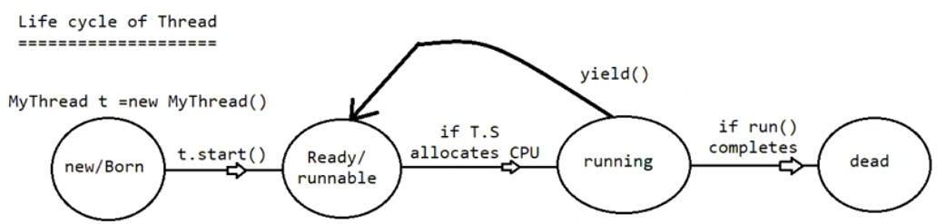
- If run() method completes:
  - Thread enters Dead state.

🔹 Example Program (With Clear Comments)
class MyThread extends Thread {
@Override
public void run() {
for (int i = 1; i <= 5; i++) {
System.out.println(Thread.currentThread().getName()
+ " is running : " + i);
// Hint to scheduler:
// "I am ready to give chance to other same-priority threads"
Thread.yield();
}
}
}
public class YieldExample {
public static void main(String[] args) {
MyThread t1 = new MyThread();
MyThread t2 = new MyThread();
t1.start(); // Both threads enter Runnable state
t2.start();
// Scheduler decides which thread runs first.
// When one thread calls yield(), the other may get chance.
// But execution order is NOT guaranteed.
}
}

🔹 Key Difference: yield() vs sleep()
yield() | sleep()
Gives chance to same-priority threads | Pauses thread for fixed time
Only a hint | Guaranteed pause
No time parameter | Requires time parameter
May be ignored by OS | Always works
Does not release locks | Does not release locks

🔹 Very Important Missing Concept
⚠ yield() does NOT:
- Guarantee context switch
- Guarantee fairness
- Guarantee another thread will run
- Change thread priority
- Release monitor locks
It only moves thread from:
Running → Runnable
That’s it.

🔹 Real-World Analogy
Imagine you are speaking in a group discussion.
When you call yield(), you are saying:
“If someone else wants to speak now, they can speak.”
But:
- If nobody speaks → you continue.
- If many people want to speak → moderator (scheduler) decides.

🔹 When Should We Use yield()?
In real-world applications:
- Rarely used.
- Mostly used for:
  - Testing
  - Debugging
  - Improving responsiveness in special cases
It is not recommended for thread coordination.

Eg: Yeild_Method

join() Method in Java (Very Simple Explanation)
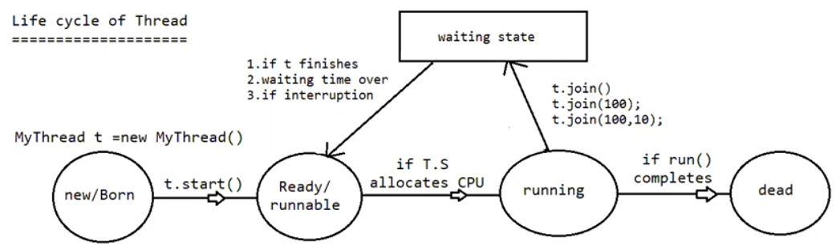
🔹 What is join()?
If one thread must wait until another thread finishes, we use join().
It is used for dependency between threads.

🔹 Simple Meaning
If:
t1.join();
It means:
The current running thread will wait until thread t1 finishes.
The waiting thread goes into Waiting state.
After t1 completes execution:
- Waiting thread moves back to Runnable state
- Then continues execution when CPU is given

🔹 Real-Life Example (Very Clear)
Wedding example:
- Venue fixing → t1
- Wedding card printing → t2
- Wedding card distribution → t3
You cannot print cards before venue is fixed.
You cannot distribute cards before printing.
So:
- t2.join() → wait for t1
- t3.join() → wait for t2
This creates order of execution.

🔹 Prototype of join()
public final void join() throws InterruptedException
public final void join(long ms) throws InterruptedException
public final void join(long ms, int ns) throws InterruptedException
Meaning:
- join() → Wait until thread completes
- join(1000) → Wait maximum 1000 milliseconds
- join(1000, 100) → Wait 1000 milliseconds + 100 nanoseconds

🔹 Important Concept
If a thread is in waiting state because of join() and:
- Another thread calls interrupt()
Then:
- InterruptedException occurs
- It is a checked exception
- Must be handled using try–catch or throws

🔹 Thread Life Cycle with join()
Step-by-step:
Thread t = new Thread(); // New / Born state
t.start(); // Runnable state
- If scheduler gives CPU → Running state
- If currently running thread calls:
  - t.join()
  - t.join(1000)
  - t.join(1000, 100)
→ It enters Waiting state
- Thread will return to Runnable state when:
  - Target thread finishes
  - Waiting time expires (for timed join)
  - Interrupted
- When run() completes → Thread enters Dead state

🔹 Example 1: Main Thread Waiting for Child Thread
Eg: Join_Method_Eg1
What happens?
- Main thread calls t.join()
- Main thread enters Waiting state
- Child thread completes execution
- Main thread resumes

🔹 Example 2: Child Thread Waiting for Main Thread
Eg: Child_Thread_Waiting_For_Main_Thread
Here:
- Child waits for main
- After main finishes → child resumes

🔴 Important: Deadlock Situation
If:
- Main thread waits for child (t.join())
- Child thread waits for main (mainThread.join())
Both are waiting for each other.
No one finishes.
This is called Deadlock.

🔹 Example: Deadlock
Eg: DeadLock
Program will hang forever.

🔥 Important Missing Points
1️⃣ join() does NOT release locks
If thread is inside synchronized block and calls join(), it still holds the lock.

2️⃣ join() internally uses wait()
Inside Java implementation:
- join() uses wait()
- That is why it throws InterruptedException

3️⃣ join() is always called on the thread object to be waited for
Example:
t.join();
Means:
Current thread waits for t.
Not the opposite.

4️⃣ Difference Between sleep() and join()
sleep() | join()
Makes current thread sleep | Makes current thread wait for another thread
Time-based | Thread completion-based
Does not depend on other thread | Depends on another thread
Does not release locks | Does not release locks

🔹 Simple Final Definition
join() is used when one thread must complete its work before another thread continues.
It creates execution order between threads.

